4) List and Dictionary

Agenda
- List
- Dictionary

Lists
So far we have worked with primitive data types that can only store one piece of data: strings, integers, floats, and booleans.
Let's see some examples:
But there's a data type, that can hold multiple pieces of data. It's called a list. Let's see how it looks like:

Sorting
Lists have some useful features, like sorting:

For-in loop
You can even go through a list with a for loop and print each item separately:
Pretty cool, huh? :)

But where does this come in handy?
For example in our "Guess the secret number" game. Right now we are storing only one score in the score.txt file - the best one.
But what if we'd want to store all of the results and then sort them from the best to the worst? And print out, for example, the top 3?
We could definitelly use a list. Let's do it!

Start from scratch
Let's delete all the file code that we added before, so our game looks as it did in the beginning of the lesson:
You can also create a new Python file and add this code in it (and keep the old code in the previous file).

Create the score_list.txt file
Open the score_list.txt file and add an empty list in it:

Read the text file
Let's open the text file inside our Python script and read the contents of the file. Add this piece of code just above the while loop:
Note the json library that we used. This library will help us seamlessly convert between a list and a string (we can only store strings in a text file).
So make sure you import the json library in the top of the Python script:
If you run the program now, it will show you an empty score list. So let's make our program add some data into it.

Insert data into a list
We add data to a list using the .append() method. Add this line of code after the if guess == secret: line:

Save the list into the text file
Now let's save the score list back into the score_list.txt file:
Play a few games. You'll see that the scores list is growing bigger and bigger.

Sort the list
As you can see, the list is not sorted from the lowest to the biggest number. So let's sort it and show only the top 3 scores. Add this code just above the while loop:
As you can see, [:3] helps us show only the first three elements from a list.
Pretty cool, right? But this is not all. We can make our data storage even better! How? With dictionaries!

Dictionary
The last thing we'll learn today is called a dictionary.
It's a data structure similar to a list in a way that it can hold many pieces of data. But with one key difference - you can actually name these pieces of data.
Let's say you'd like to have a list of features that some object has. For example: a box. A box has length, width and height. Let's write this using a Python list:
Ok, but how do we know which of these numbers represents length, width or height?
Here comes the power of dictionaries. In a dictionary, each piece of data (called value) has an associated key. So a box dictionary would look like this:
This makes box features much more clear.
Even clearer version would be to have keys also hint a unit, like "height_cm" (centimeters) or "height_in" (inches).
We can access the data in a dictionary like this:
Or like this:
Data in a dictionary is stored in a so called "key-value" format. Which is the same as in a paper dictionary, that each of us has already seen:
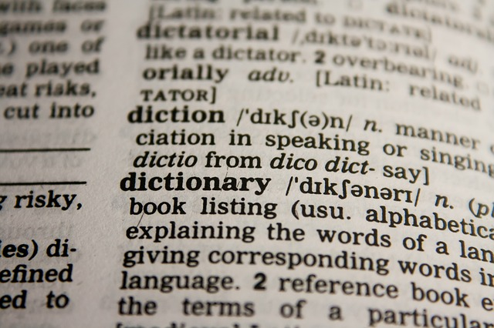
A word is a key, and the description of the word is its value.
Also note that Python lists use square brackets [] , while dictionaries use curly brackets {}.

So when to use list and when to use a dictionary?
If you want to group data of the same kind, you'd use a list. Example: a list of European cities:
But if you'd like to group data of different kinds, you'd use a dictionary:
Important: Note that keys in a dictionary must be unique. There can't be two identical keys in the same dictionary.

How can we use this in our game?
Let's say we want to save the date when each score was made.
We can get the current date and time using this neat Python library:
In order to store the current time together with a score, we'll use a dictionary:
And because we will have many score_data elements (one for each game played), we'll store them all in a list. It will look something like this:
So we will combine the power of lists and dictionaries together. Let's build the thing!

Empty the score_list.txt
First let's empty the score_list.txt. It should have an empty list in it:

Append a dictionary
Next let's change the line where we have score_list.append(attempts). Change it into this:

Replace the list sorting
And finally let's replace these list sorting lines of code:
With this for loop:
We removed sorting the list from the lowest to the highest number of attempts, but you'll do this for a homework.
Now let's play the game a few times. As you can see in the score_list.txt, our database now includes both the number of attempts and the date each game was played.

Q&A
Any question?
If there's enough time after Q&A, students can start working on their exercises and homework.

Homework 4.1: Add some more data in the dictionary
For now our game only stores the number of attempts and the date. Let's also store the name of the player and the secret number in each game.

Homework 4.2: Add unsuccessful guesses into the dictionary
During the game, collect user's unsuccessful guesses and then store them in the dictionary under the name "wrong_guesses".

